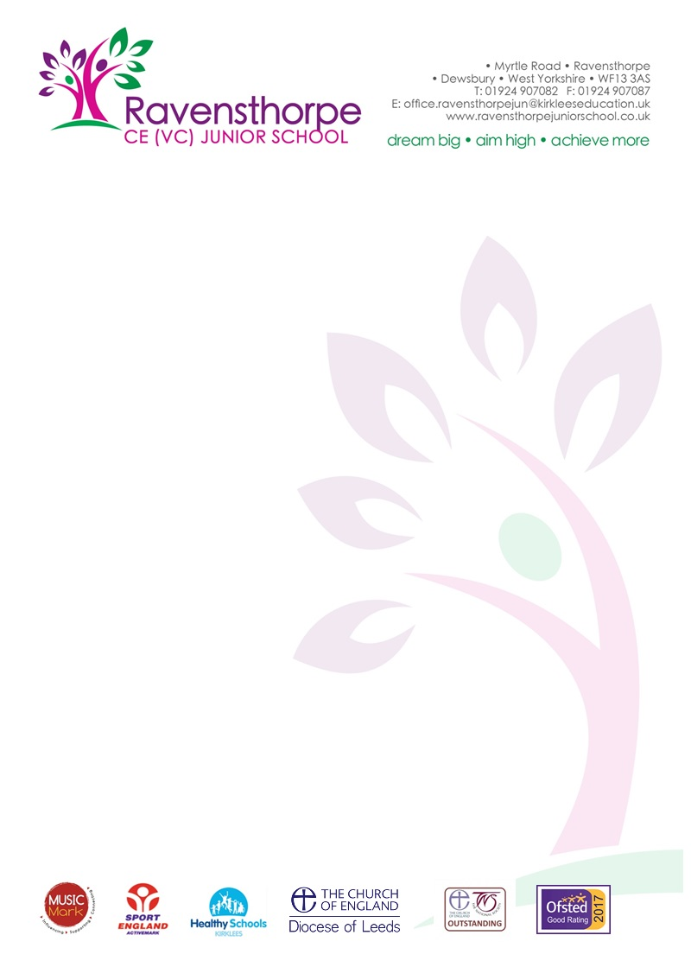

Tuesday 15th February 2022
Dear Parent/Carer
What a busy half-term it has been! Even though next week is a holiday, we are already busy planning for next half-term. Please don’t forget that there is a lot of information on our website and our app. Make sure you have the app downloaded in order to be kept up-to-date with the latest news.
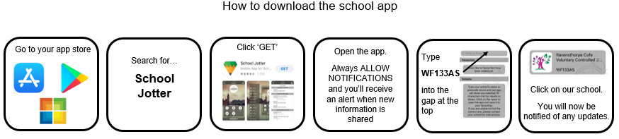
Attendance and Punctuality
Well done to all of the pupils who attend school every day and who rarely have time off. Unfortunately, attendance is still an issue for many of our pupils. I would like to remind you that attending school is important for your child’s future. Parents are responsible for ensuring that their children attend school regularly and on time, giving your child the best possible start in life. Students who miss school often fall behind in their work and do less well in their SATs. Good attendance will help your child to develop strong friendships, social skills, team values and life skills.
If we have concerns about your child’s attendance, you will be contacted by the school, either via phone or letter. We understand that managing your child’s attendance can be difficult. If you require support, please contact Miss Nelson-Williams (our Attendance Officer) or Mrs Horne, both of whom can help you with your child’s attendance.
Many parents have requested leave of absence (including term-time visits abroad). Can I remind you that permission for these will only be granted in exceptional circumstances. If you take your child abroad, you are likely to receive a fine. Repeated offences of leave of absence may result in the matter being directly prosecuted in Kirklees Magistrates’ court. More details about attendance can be found on our website.
World Book Day
It’s that time again – our favourite day of the year is back! After two years of disruption, World Book Day will finally be celebrated once again on Thursday 3rd March. The children will be allowed to come in costume, dressed as their favourite book character! The theme for this year is ‘you are a reader.’ They will have the opportunity to recommend their favourite books, read with other children around school and have a fun-filled day with their class carrying out activities based around their class book. It has always been a day which the children love to celebrate and I hope they will continue to develop a love for reading.

School Council – Fruit and Recycling
After half-term, our School Council will be re-introducing the selling of fruit at morning break. Fruit is a good way to restore energy levels and give your child a boost mid-morning. Initially, they will sell just bananas and apples; the fruit will be distributed in a COVID secure way. If your child would like to buy fruit, each piece will cost 20p. Money should be sent into school with your child.
Can we also remind you that one of our aims as a School Council is to promote recycling. We’re very proud of the work we’re doing in school. Do you need advice on how to recycle more at home? Ask the school for more details.
PE Kit
We would like to remind you that our PE kit is as follows:
- Blue shorts/leggings/tracksuit bottoms
- White t-shirt
- Trainers
Many children have been arriving at school wearing incorrect PE clothing. Please ensure that your child is wearing the appropriate kit. Non-branded clothing can be bought at most supermarkets. If you need help to finance the kit, please get in touch with the school office.

Finally, we would like to wish you a happy half-term break. The pupils will be back in school on Monday 28th February.

Miss J L Alderson
Headteacher

