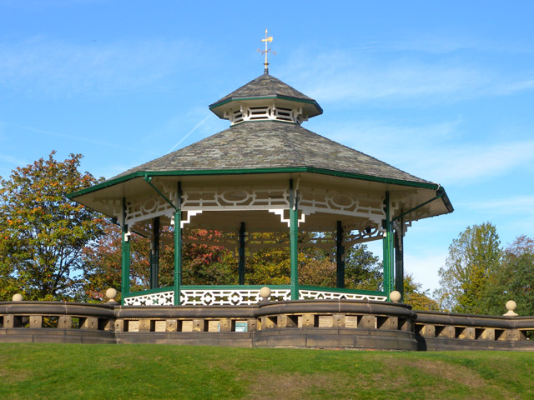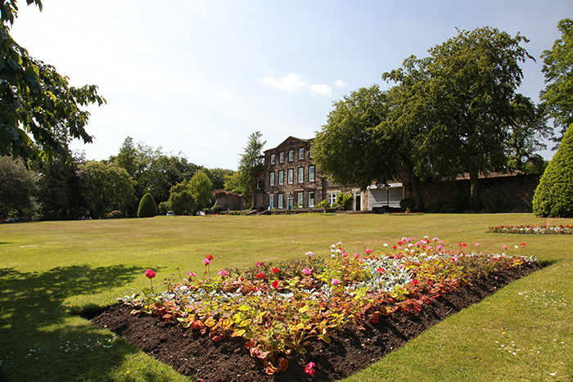

MHST Wellbeing Walks & Family Picnics

Throughout the Summer holidays, we are holding Wellbeing walks and Family picnics in the parks around Kirklees.

All families are welcome to come along and join us.
- Thursday 29th July 1pm-3pm – Wellbeing Walk @ Crow Nest Park, Dewsbury – Meet at the cafe
- Tuesday 3rd August 11am-1pm Walk & Picnic @Beaumont Park, Huddersfield – Meet at the water feature.
- Thursday 12th August 12noon-2pm Walk & Picnic @ Savile Town Park, Savile Town – Meet at the playground.
- Wednesday 18th August – 11am-1pm Walk & Picnic @ Greenhead Park - Meet at Main entrance (Junction pub roundabout)
- Monday 23rd August – 10am-12noon - Chill n Chat @Northorpe Hall
- Friday 3rd September – 11am-1pm – Walk & Picnic @ Wilton Park. Meet At the pond.

For further details please contact parentmhst@northorpehall.co.uk

