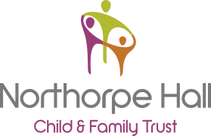
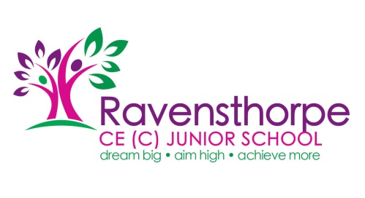

Parent Drop-In Session:
Date: Tuesday 17th March 2020 at 1:30pm
Place: Ravensthorpe Junior School
All Welcome to attend
Salma Mahmood, Family Emotional Health Worker from Northorpe Hall, will be running an informal drop-in session for parents. The aim of the session is to meet with parents and obtain feedback about what information and services they would like to access to help support their children’s emotional wellbeing.
Refreshments will be available.
Please enter school via the main reception. If you would like any further information, please contact Laura Horne (Safeguarding Officer) on 01924 907082.

