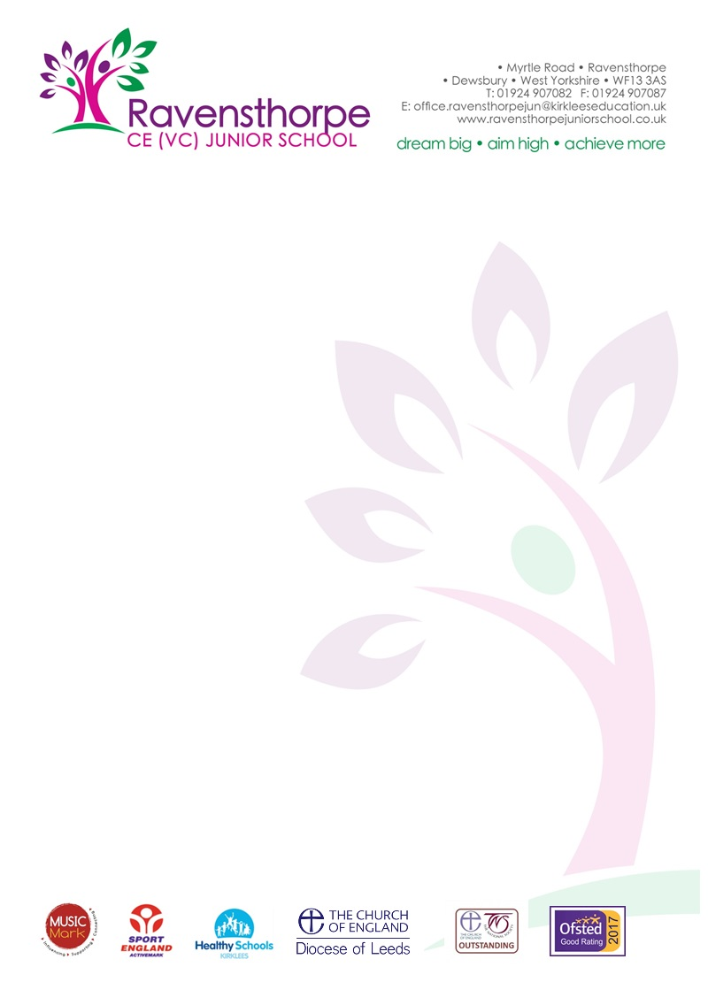

Thursday 27th February

Re: COVID–19 Advice for schools and educational settings

You may be aware that advice for travellers from affected areas has recently changed and it has come to our attention that this may affect children and staff returning from school trips. Please be aware that this is a fast evolving situation and we will continue to share any new advice at the earliest opportunity.

As of today (25th February) advice for returning travellers is as follows;

1) If you have returned from the following areas since February 19, call NHS111 to inform them of your recent travel, stay indoors and avoid contact with other people even if you do not have symptoms:

- Iran
- Specific lockdown areas in Northern Italy* as designated by the Government of Italy
- Daegu or Cheongdo, Republic of Korea)
- Hubei province, China (returned in the past 14 days)

* Bertonico • Casalpusterlengo • Castelgerundo • Castiglione D'Adda • Codogno • Fombio • Maleo • San Fiorano • Somaglia • Terranova dei Passerini: • Vo

2) If you have returned from the following areas since February 19th and develop symptoms, however mild, you should stay indoors at home and avoid contact with other people immediately and call NHS111. You do not need to follow this advice if you have no symptoms.

- Northern Italy (see map)
- Vietnam
- Cambodia
- Laos
- Myanmar

3) If you have returned to the UK from any of the following areas in the last 14 days and develop symptoms of cough or fever or shortness of breath, you should immediately stay indoors and avoid contact with other people, call NHS 111 to inform them of your recent travel to the country.

- Other parts of China outside Hubei province
- Thailand
- Japan
- Republic of Korea
- Hong Kong
- Taiwan
- Singapore
- Malaysia
- Macau

Information for the public: https://www.gov.uk/guidance/wuhan-novel-coronavirus-information-for-the-public

Yours sincerely

Public Health England

