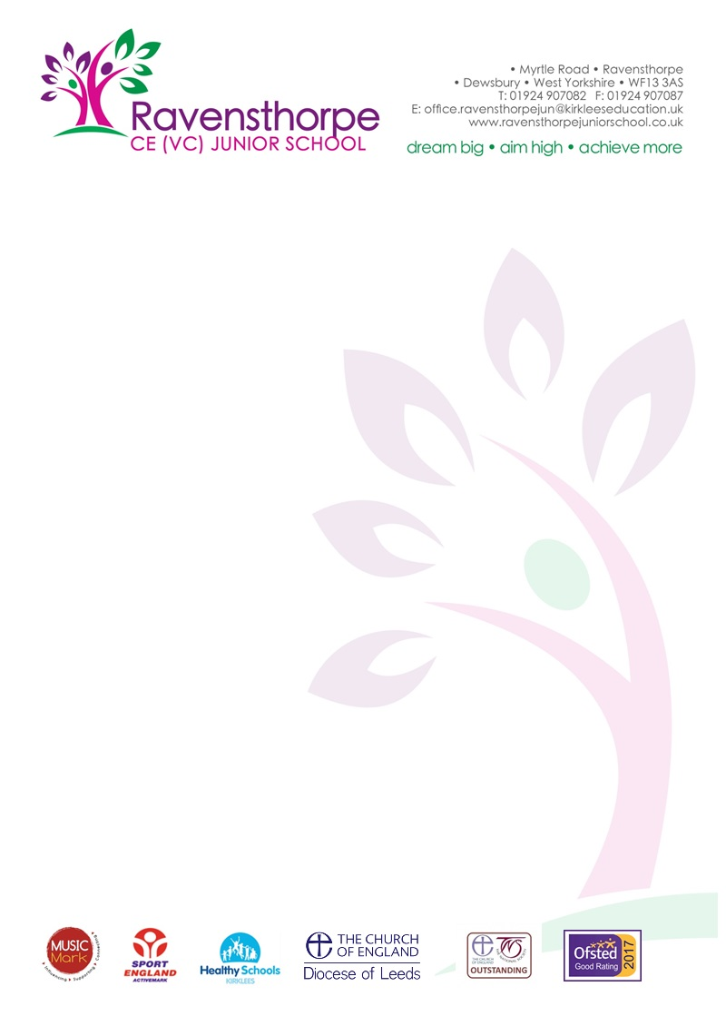

Thursday 13th February 2020

Dear Parent/Carer

I am writing to inform you that I will be retiring from my post as Head teacher of Ravensthorpe CE (VC) Junior School at the end of this academic year.
Whilst it has been a difficult decision to leave such an exceptional school, I believe that, after 34 years in teaching and 12 years as the Head teacher of two Kirklees schools, it is the right time for me to step down and enjoy my retirement.
During my time as Head teacher, I consider myself very fortunate and privileged to have worked with some amazing students and talented staff and governors. I wish to say a special ‘thank you’ to our governing body. They have provided me with challenge and support in equal measure over the last five years and have played a significant part in the success we have enjoyed.
The Governors have now advertised the post nationally and I have every confidence that they will appoint an outstanding candidate who will continue to work with all groups to bring further success to our school. Father Wildey, our Chair of Governors, will write to you once a new Head teacher is appointed.
May I remind you that school closes tomorrow for the half term holiday. We will open again on Monday 24th February.

Yours sincerely

A S Parkin
Head teacher

