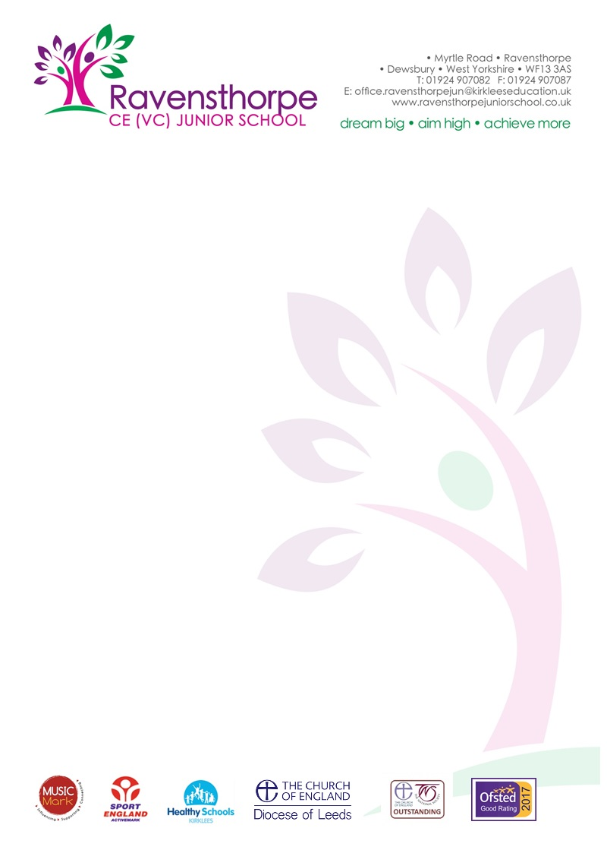

Dear Parents/Carers 3rd February 2020

On Wednesday 5th March 2020, we will be holding a Harry Potter Themed Lunch as part of World Book Day. The menu is on the reverse of this letter. If your child normally brings a packed lunch to school, or goes home for dinner, they have the option to stay for this lunch if they wish. The cost of the lunch will be £2.25. Children who receive free school meals will
receive the lunch free of charge. Please indicate your child’s meal choice on the reverse of the return slip.

The lunch should be paid in the usual way via Parentpay. Could you please make sure you credit your parentpay account under the item school lunch before Tuesday 11 February 2020 otherwise a meal will not be ordered for your child. If you require a Bar Code to pay for the lunch in cash at a PayPoint store, please tick the box below and the office will
arrange for this to be sent home to you. Please bring your receipt in to school when you have paid for the lunch as proof of payment before the deadline of Tuesday 11th February 2020.

Yours faithfully

Mr A S Parkin
Headteacher
______________________________________________________________________

Name of Child ……………………………………...Class ………………

Please indicate your child’s meal choice on the reverse of the return slip.
I would like my child to have a Harry Potter Lunch and I
will pay the £2.25 on my Parentpay account before Tue 11 February 2020

I would like my child to have a Harry Potter Lunch however I need a Bar
Code to pay £2.25 at a PayPoint store before Tue 11 February 2020

My child receives free school meals and I would like them to receive a
free school Harry Potter Themed Lunch

Signed ………………………………………………….. Parent/Carer

World Book Day – 5th March 2020
Harry Potter Meal Choice
Harry’s Chicken Cauldron – Halal

Harry’s Chicken Cauldron – Non-Halal

OR
Hogwarts Wizardry Falafel Burger

All meals are served with Bertie Bott’s Beans or Deathly Hallow Corn and Muggles Potatoes

