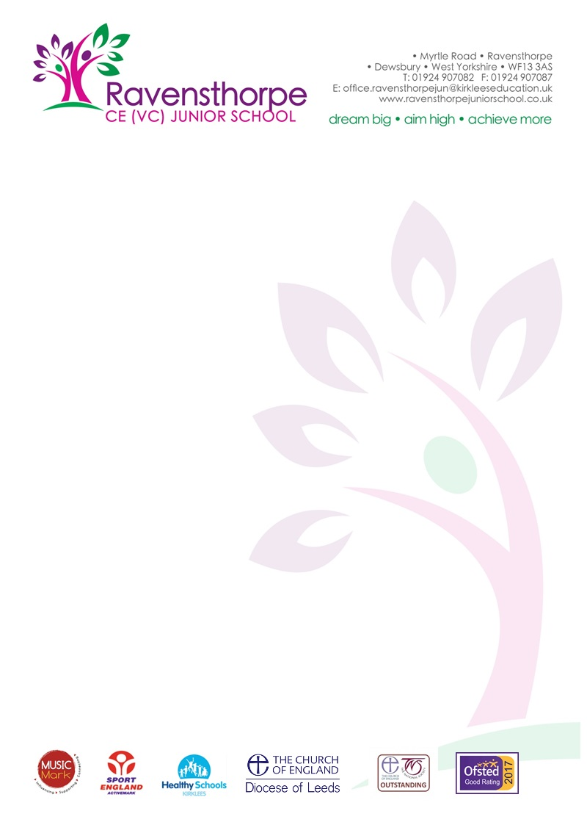

Dear Parents/Carers Friday 19th July 2019

SATs Results 2019
Our Year 6 SATs results continue to be impressive. Although our Reading scores were down slightly this year, we were well above the National and Kirklees averages for: Writing, Grammar, Punctuation and Spelling and Maths. Thank you to all our Year 6 teachers and to those staff who helped with the administration of the tests.

Year 4 Multiplication Tables Check
This was the pilot year for the Government’s Year 4 Multiplication Tables Check. This is a National test and the results will be reported fully next year. Early indications suggest that the performance of our children will place us easily in the top 10% of schools in the country. My thanks to Mrs Wood, Mrs Morton and all the Year 4 staff for the hard work they have put into improving the children’s knowledge of multiplication tables.

Leavers
We send our very best wishes to all our Year 6 children who are leaving for High School. We hope that they will take with them many happy memories of their time here. The end of term production of, ‘Ali Baba and the Bongo Bandits’ was truly magnificent - we were very proud of every one of them.

Year 5 - Transfer to Secondary School
The transfer to secondary school process for September 2020 will begin on 1 September 2019. Open evenings at the majority of Kirklees high schools and academies will be taking place during September and October 2019. More detailed information about the transfer process is available at www.kirklees.gov.uk/admissions from 1 September 2019 and the full secondary school guide for parents will also be available on this link for download and/or print. Dates of open evenings can also be seen on our school website: www.ravensthorpejuniorschool.co.uk
Goodbye
We are also saying ‘goodbye’ to a number of staff today. Mrs Mitchell, Miss McArdle and Miss Khalid are all leaving us to start teacher training courses in September. Miss Raje will continue her teaching career in Qatar – I hope that her new classroom has air conditiong – she’ll surely need it! Miss Regan leaves to start her teaching career at Headfield Junior School. We wish all of them the very best for the future.

School Dinners
From September school meals will cost £2.25 per day (£11.25 for the week). There is information on our website if you think that your child is entitled to free school meals.

Uniform
In future, sweatshirts, polo shirts, cardigans, school bags etc. with our school logo, will only be available from www.myclothing.com. We still have limited numbers of some sizes and will hold another sale in the Autumn term.

Swimming – Year 4
All our Year 4 children take part in swimming – it’s part of the curriculum. If your child is in Year 4 next year, they will need a swimming cap. You will be able to purchase these during the first week of term - £2 each. Please give the money to your child’s new class teacher in September.

Summer Reading Challenge
The Summer Reading Challenge takes place every year during the summer holidays. You can sign up at the Greenwood Centre, then read six library books of your choice to complete the challenge. There are exclusive rewards to collect along the way, and it’s FREE to take part! The theme for 2019 is SPACE CHASE. For more information visit: www.summerreadingchallenge.org.uk

Dates for 2019-20
Our school prospectus includes all the holiday dates and term times dates for 2019-20. You can download the prospectus from our school website: https://www.ravensthorpejuniorschool.co.uk/
Please remember not to book holidays during term time.

Finally, can I say an enormous thank you to all of the staff in school. They work tirelessly all year to do the best for our children. May I wish them, and all of you, a relaxing and enjoyable Summer holiday.

Very best wishes

A.S. Parkin
Headteacher

School opens on Tuesday 3rd September

