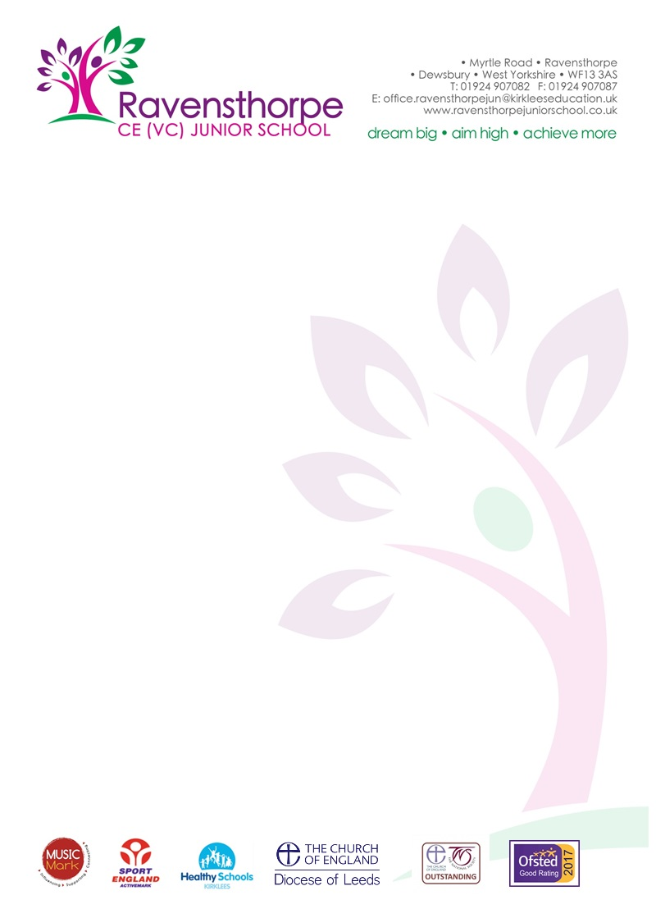

Thursday 6th June 2019

Dear Parent/Carer,

The NSPCC’s Speak out. Stay safe. programme is visiting our school to make sure our pupils have the knowledge and understanding they need to stay safe from abuse.
I’m pleased to tell you that we will be working with the NSPCC, the UK’s leading children’s charity, who’ll be delivering their Speak out. Stay safe. programme on the 10th & 11th June 2019. This is a nationwide programme for every primary-school-aged child in the UK and Channel Islands. With the help of their friendly mascot Buddy, they’ll be presenting an assembly to the children in our school as well as a workshop for Years 5 & 6.

"NSPCC has helped me to build the confidence to tell people about my worries and problems." Child’s feedback

What is the Speak out. Stay safe. programme?
Through child-friendly, interactive assemblies and workshops their specially trained staff and volunteers will give our children information about how to keep themselves safe from harm and how to get help if they have any worries, sensitively discussing issues like bullying and sexual abuse, without using scary words or adult language.
We have studied the content of the materials and heard from other schools who have participated and are extremely confident that they are appropriate for primary-school-aged children. By the end of their visit, we’re convinced children will feel empowered – knowing how they can speak out and stay safe.
“My daughter thought the volunteers were fantastic, really real people, very warm and friendly.” Sally, Prestatyn
If you would like any more information about the Speak out. Stay safe. programme you can come in to speak to me or visit the NSPCC website nspcc.org.uk/buddy
Talking PANTS with your children
The NSPCC’s work in schools will help encourage conversations about staying safe – and they have a number of child-friendly materials to help you carry on the conversation afterwards. That includes ‘Talk PANTS’, a simple way for parents to help keep children safe from sexual abuse – without using scary words or even mentioning sex.
The guide uses the rules of PANTS to teach children that their body belongs to them and them alone. You can find out more and download the free resources at nspcc.org.uk/pants

If you’d like to know more about the NSPCC’s work, or take a look at the wide range of information and advice which is available for parents and carers, please visit their website nspcc.org.uk/parents

Yours sincerely,

Mr. A S Parkin (Head Teacher)

