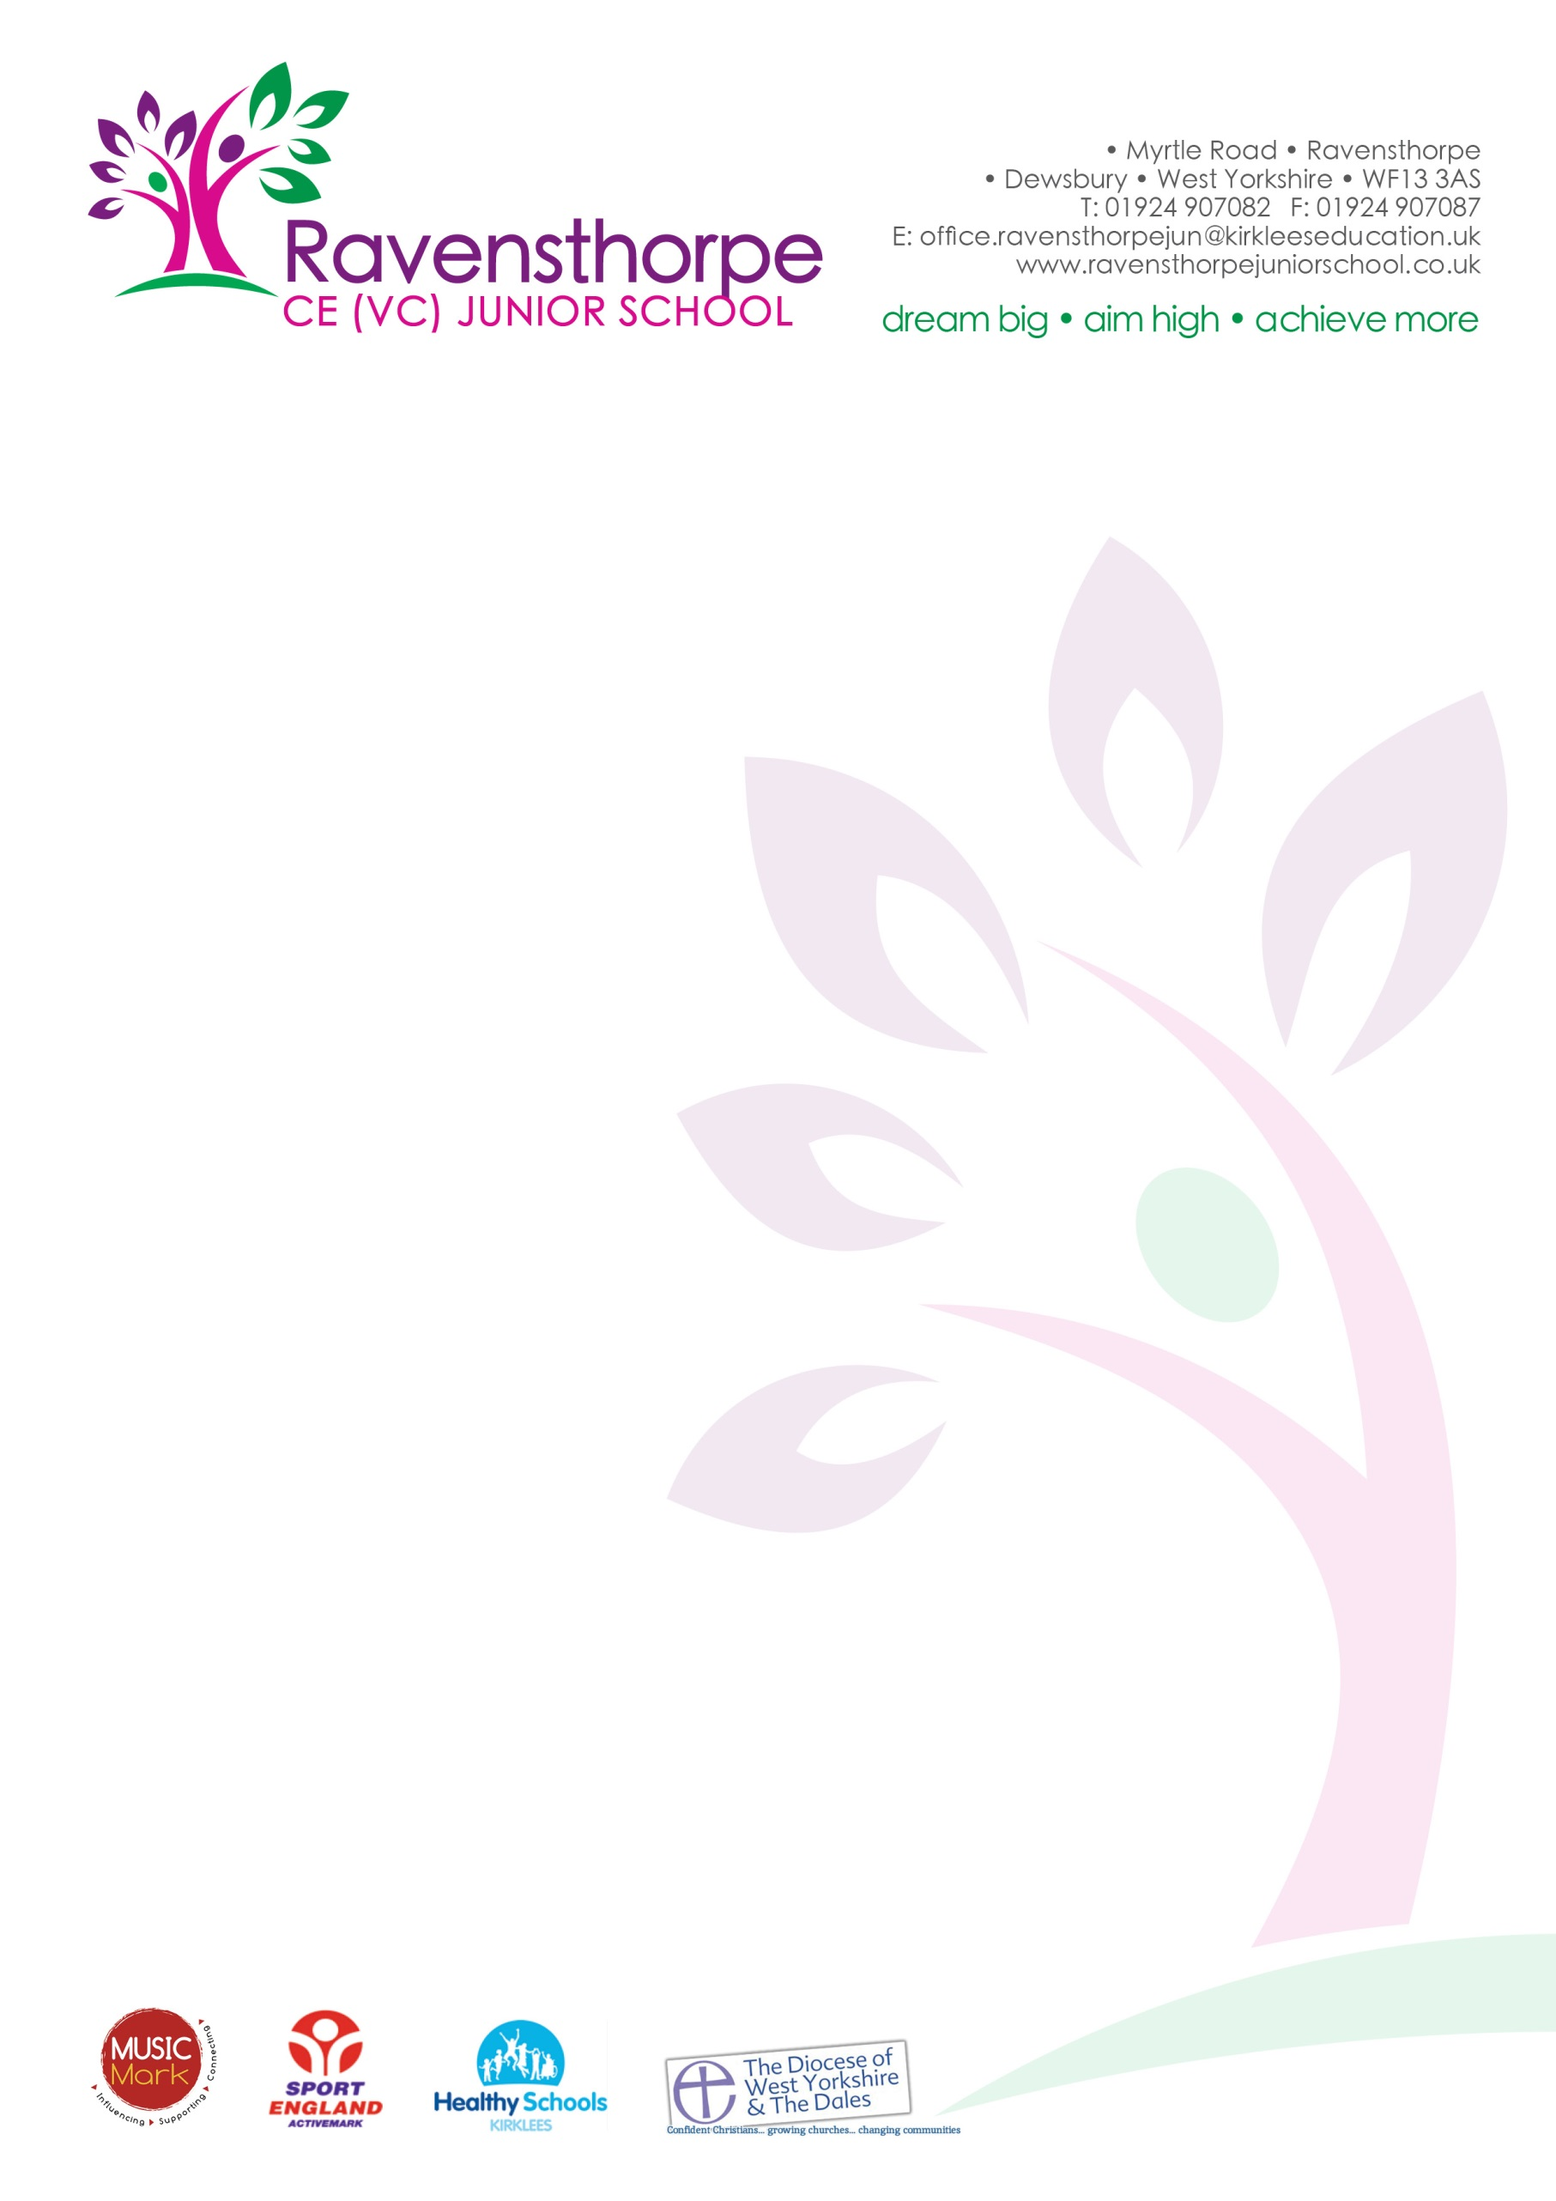
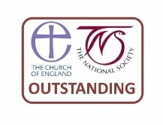

Thursday 29th March 2018
Dear Parents

There has been a significant increase recently in the number of requests to take children out of school during term time. May I remind you that I can only authorise absence in exceptional circumstances. Family weddings, cheaper flights and cooler temperatures do not qualify as exceptional circumstances, neither do surprise holidays booked by other members of the family. Examples of exceptional circumstances are:

- If a parent is service personnel and is returning from a tour of duty abroad where it is evidenced the individual will not be in receipt of any leave in the near future that coincides with school holidays
- Where an absence from school is recommended by a health professional as part of a parent or child’s rehabilitation from a medical or emotional issue
- The death or terminal illness of a close relative, only if the Headteacher is satisfied that the circumstances are truly exceptional

If you are considering taking your child out of school, you must make an appointment to see me. Parents can be issued with a Fixed Penalty Notice by the school, local authority or police, for their child's non-attendance. The penalty is £60 per parent for each child and this rises to £120 if paid after 21 days but within 28 days of receiving the notice.

There is a proven link between attendance and academic achievement. Children with good attendance have higher attainment and make better progress than those with poor attendance. Please help us to do the best for your children by making sure they attend school every day - unless they are ill.

Can I also remind parents of children in Year 6, that SATs week is fast approaching (week beginning 14th May). Please make sure your children do plenty of revision over the next two weeks. Encourage them and offer them as much support as you can. They will have plenty of revision materials to keep them occupied, but it’s important to remember to give them a break too.

Finally, the school closes for the Easter holiday today. We open for the Summer term on Monday 16th April. May I wish you all an enjoyable and peaceful holiday.

Yours sincerely

A S Parkin

