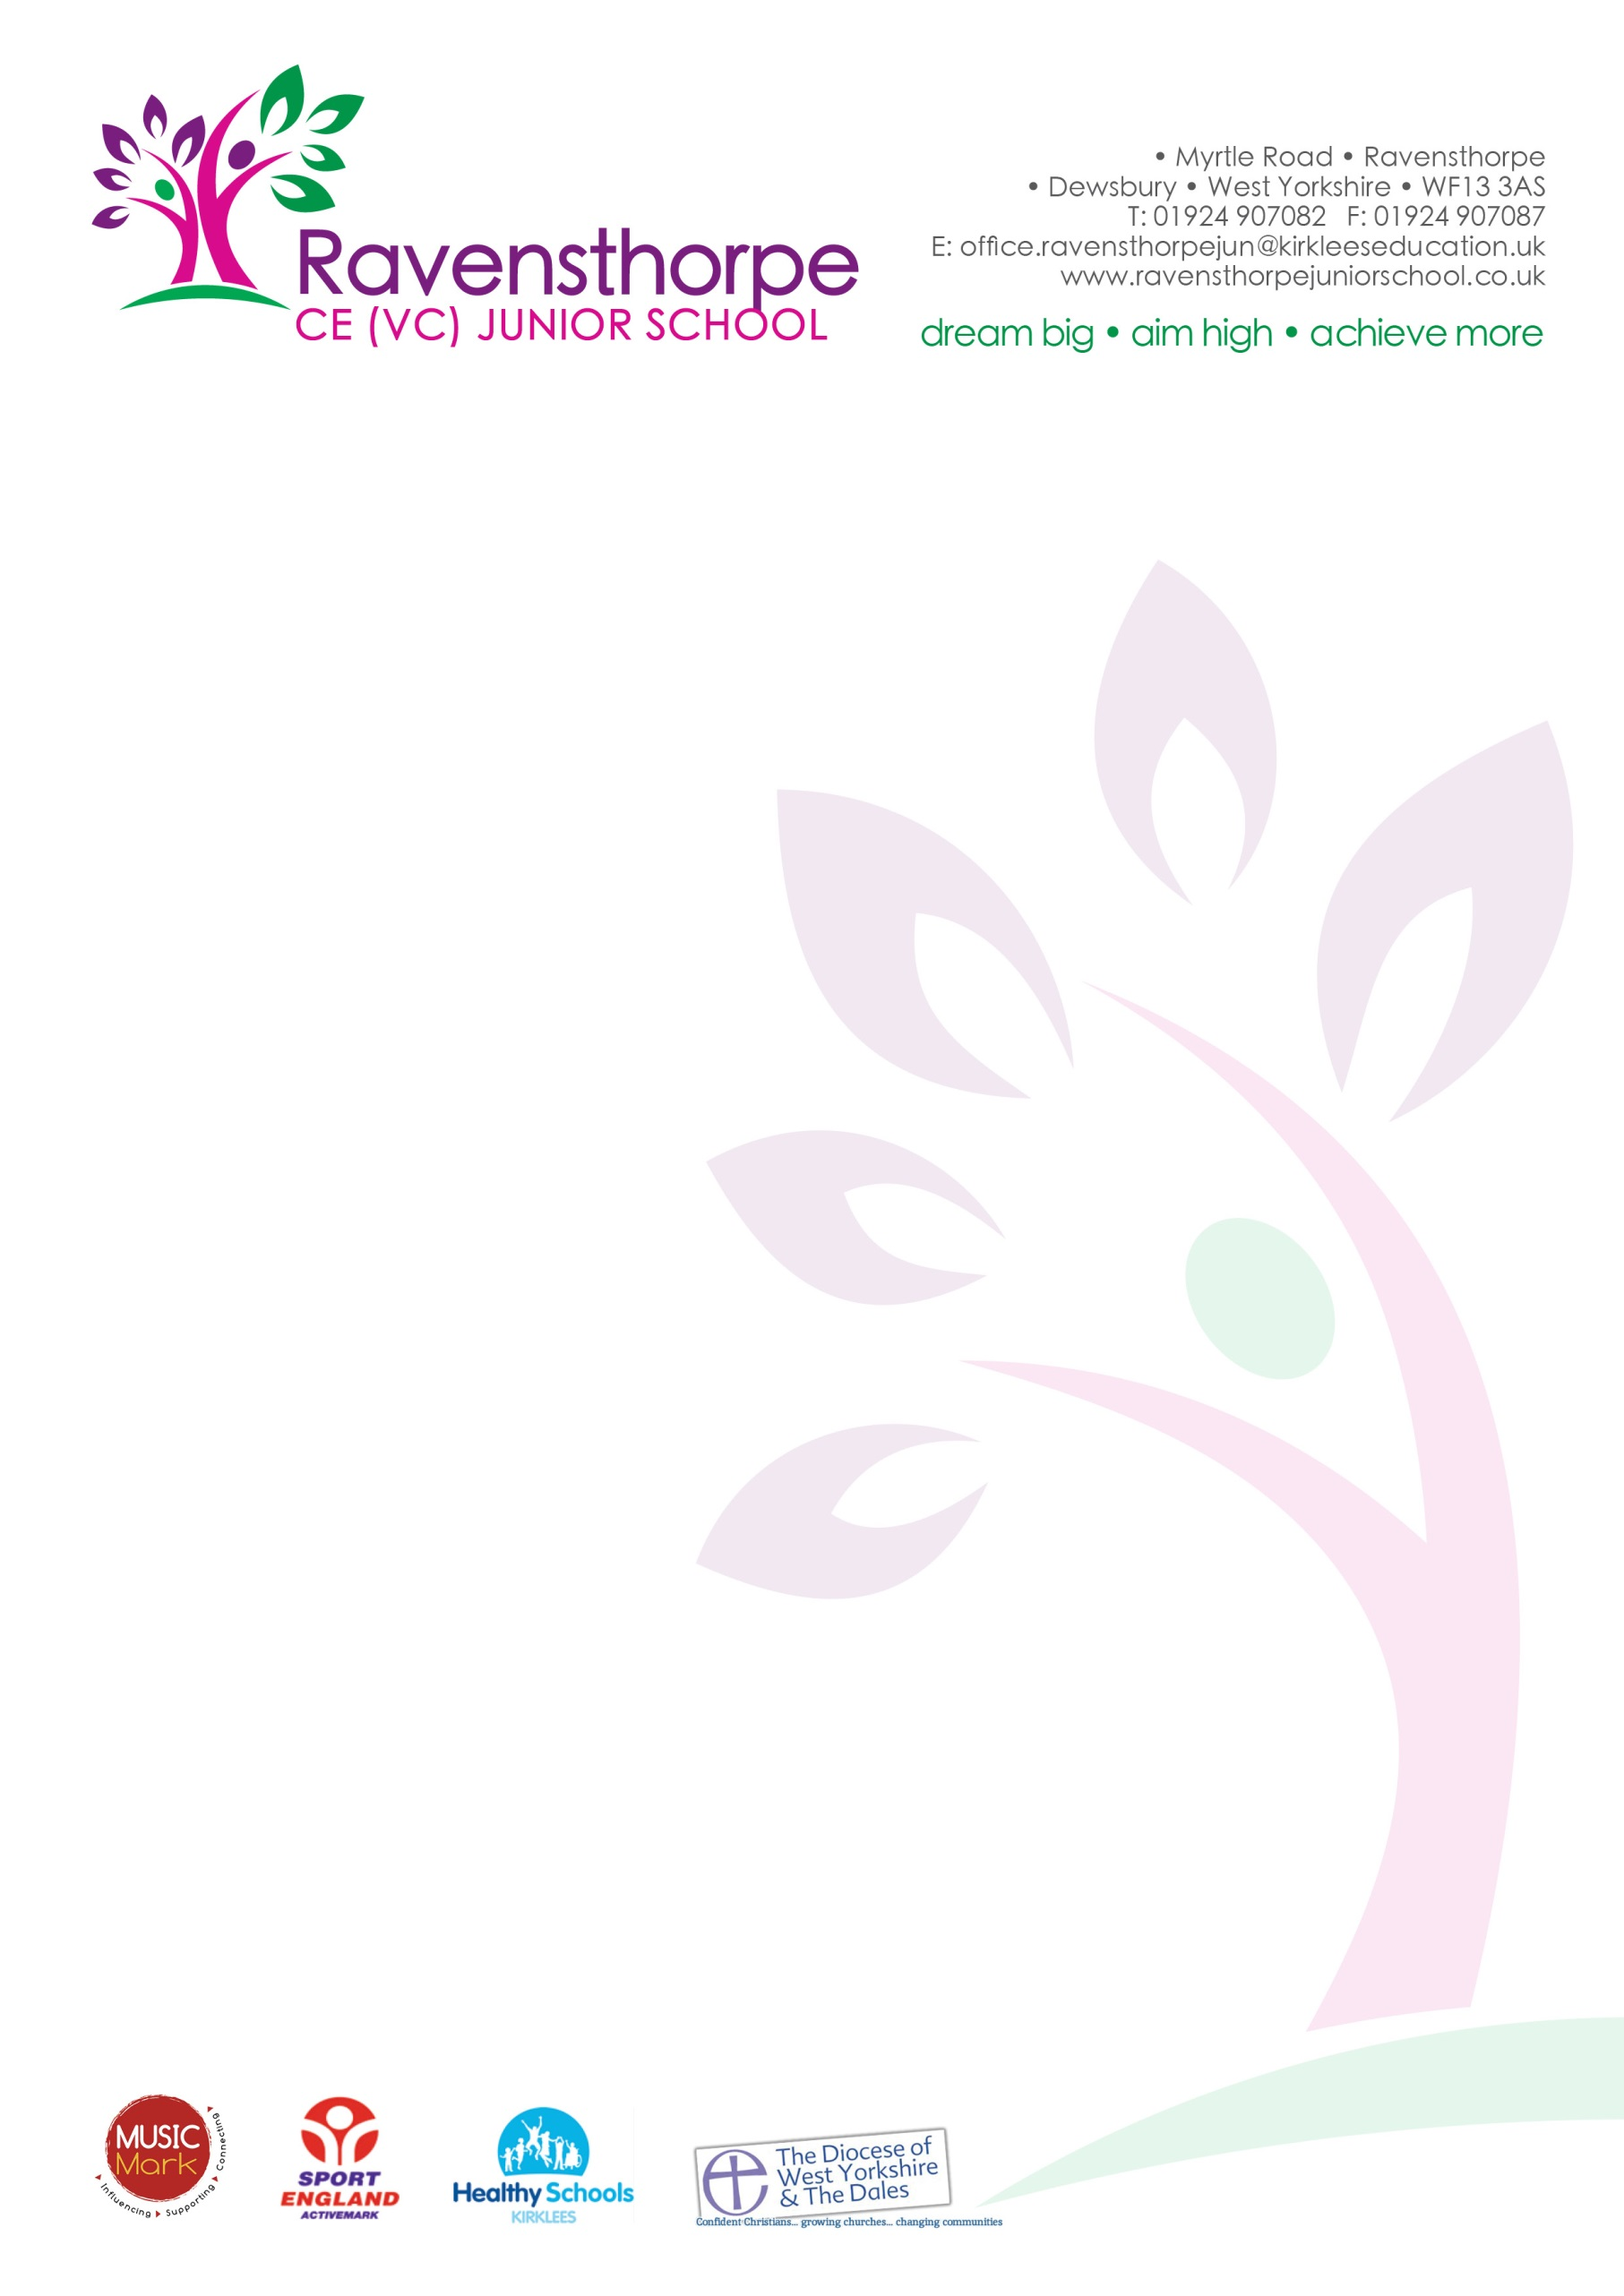

Thursday 21st December 2017
Dear Parents
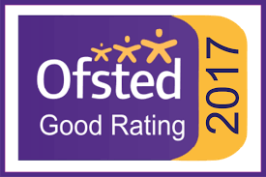
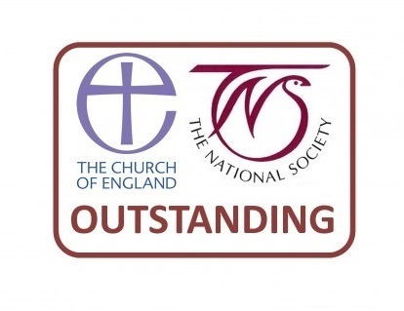
2017 has been a particularly busy year for us, but also a very successful one. In March we were visited by Ofsted and graded as ‘Good’ and then in July we had a SIAMS inspection and were graded ‘Outstanding’ in all areas. If you haven’t had chance to read either of these reports, you can find them on our school website: www.ravensthorpejuniorschool.co.uk, or on our mobile app.
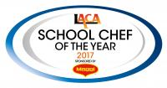

Our school chef, Tracy Healy, also won the ‘LACA School Chef of the Year’ title and you can follow her blog on our website.
The primary school performance tables were released last week and show that for the second year running, ‘there is no better performing similar school (based on pupils’ achievement at Key Stage 1) within 75 miles of Ravensthorpe Junior School.’ The progress our children made in reading and maths was in the top 10% of all schools nationally. You can find the performance tables at: www.compare-school-performance.service.gov.uk. We are also featured on page 4 of this week’s Dewsbury Reporter. Please do have a look.
There were two performances of our school nativity ‘Superstar’ this week. The children were truly brilliant and gave a stellar performance. My thanks to all the staff for their dedication and hard work in putting the show together.
May I finish by reminding you that school closes tomorrow for the Christmas holiday. We will open again on Monday 8th January 2018. From everyone in school, a very Merry Christmas and a Happy New Year.

Yours sincerely

A S Parkin

