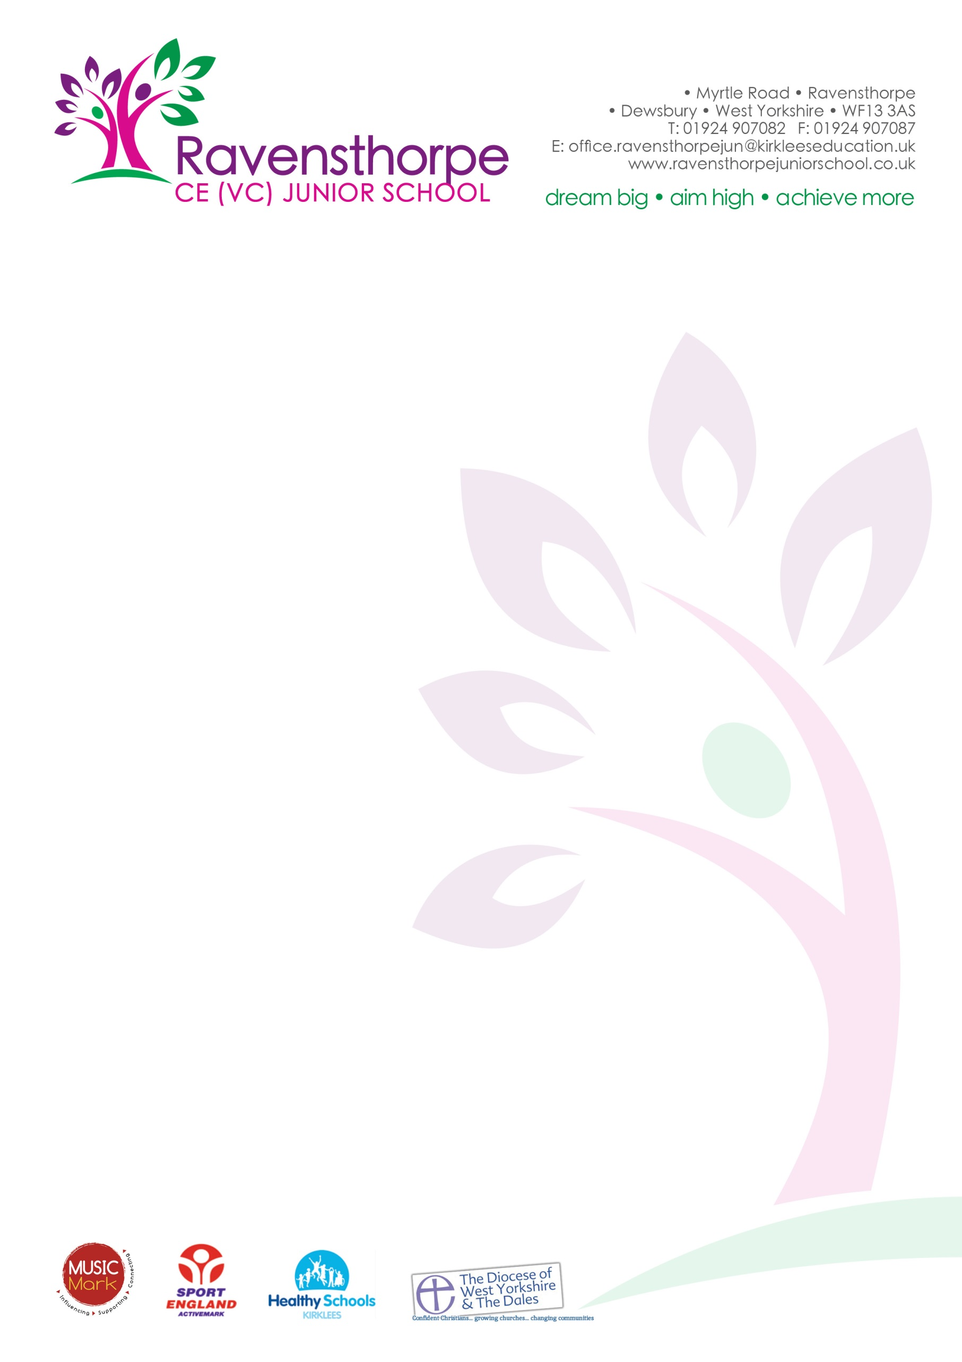

Tuesday 7th November 2017

Dear Parents

Next week, Monday 13th November to Friday 17th November, will be National School Meals Week. As part of the week, we will be hosting a ‘Roast Dinner’ event on Thursday 16th November.

Tracy Healy, our school chef – and the reigning school chef of the year, will be running a part marathon on the day and we are hoping some of the children and staff will also join in for the last few hundred metres!

The event is being supported by LACA, the organisation which voted Tracy the number one school chef in the country, and their nominated charity is the British Heart Foundation.

We plan to raise money for the British Heart Foundation by having a non-uniform day. The non-uniform day will be this Friday, the 10th November. Please support us by donating £1 (more if you can) and allowing your child to come in non-uniform.

Thank you in anticipation.

Yours sincerely

A S Parkin

