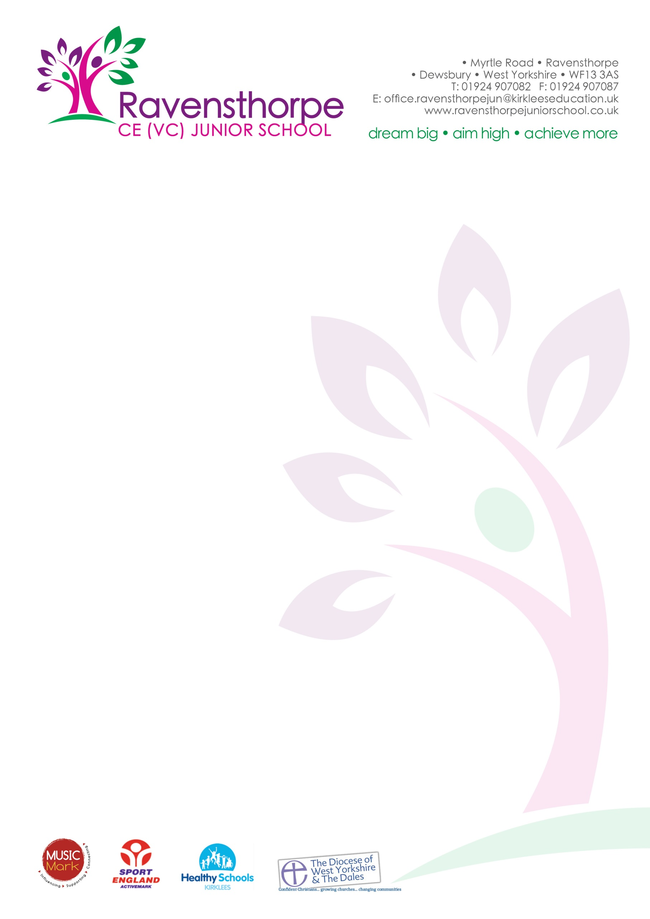

Friday 8th September 2017

Dear Parents/Carers

Welcome back to a new school year. I hope that you had an enjoyable summer and that you are ready for the year ahead.

SIAMS Inspection – outstanding
On Friday 14th July we had a full day Section 48 inspection. This is the statutory inspection of Anglican and Methodist Schools (SIAMS) which all church schools must have. The inspection evaluates our distinctiveness and effectiveness as a church school. I am pleased to tell you that we were graded outstanding in every section of the report. You can read the full report on our school website: www.ravensthorpejuniorschool.co.uk – visit the homepage and click on the SIAMS outstanding logo.

Mobile APP
If you haven’t yet downloaded our App, then please do so as soon as possible. It is the best way to receive important messages quickly (we no longer use Groupcall text messaging). The App is free and can be downloaded from the Apple App store and the Google Play Store. Please ask if you need help with this.

School Prospectus
Our 2017/8 prospectus can be viewed and downloaded from the school website. It contains information about many aspects of school life including: school meals, uniforms, admissions, holidays, the curriculum and our school rules.

Secondary Schools
If your child will be starting secondary school in 2018, you must apply online before 31st October 2017. Visit www.kirklees.gov.uk/admissions. All Kirklees secondary schools have open evenings during September and October and you can find the dates of these by clicking on the link on the homepage of our school website.

Absence from school
If your child is ill, please let us know the reason for their absence as soon as possible.
Can I also remind you that I am unable to authorise holidays during term time other than in exceptional circumstances. If you are considering taking your child out of school, then you must make an appointment to see me. If you take your child out of school without authorisation, then you are likely to incur a penalty notice. Penalty notices are £60 per child for each parent, if paid within 21 days, or £120 per child for each parent, if payment is made between 21 and 28 days. Non-payment may result in a prosecution and a fine of up to £2,500 or a custodial sentence. Please do support us in helping to improve attendance: there is a clear link between academic achievement and good attendance.
If there is anything at all we can support you with, please make an appointment at the school office.

Yours sincerely

Mr A S Parkin
Headteacher

