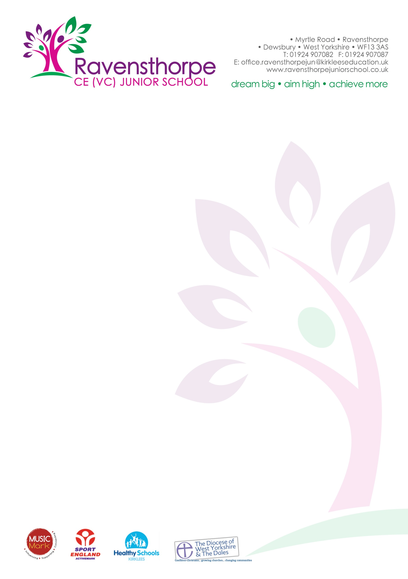

Dear Parents/Carers 21 July 2017

Inspections
It has been another busy year in school: a successful Ofsted inspection in March and an outstanding church schools inspection last week (more news of this in September).

SATs results
Our Year 6 SATs results in 2016 were well above the national and amongst the best in Kirklees. This year’s results are even better. The school performance tables, when they are published, will show this.

Leavers
We send our very best wishes to all our Year 6 children who are leaving for High School. We hope that they will take many happy memories of their time here. The end of term production, ‘Robin and the Sherwood Hoodies’ was truly magnificent - we were very proud of every one of them.

We are also saying ‘goodbye’ to Mrs Bowyer today. She has worked with commitment and dedication during her 9 years at the school. We wish her health and happiness for the future.

Mr Ellis is also leaving us to start his teaching career at Headfield Junior School. We wish him all the very best for the future.

School Dinners
From September school meals will cost £2.12 per day (£10.60 for the week). There is information on our website if you think that your child is entitled to free school meals.

Uniform
At the moment, sweatshirts and polo shirts can only be bought direct from school. The price of a sweatshirt is £7.50 and a polo shirt is £6.50. We will be selling uniform after school every day during the first week back (Tuesday 5th September to Friday 8th September).

Finally, can I say an enormous thank you to all of the staff in school. They work tirelessly all year to do the best for our children. May I wish them, and all of you, a relaxing and enjoyable summer holiday.

Very best wishes

A.S. Parkin

School opens on Tuesday 5th September at 8.50am.
website: www.ravensthorpejuniorschool.co.uk – you can download our 2017-18 prospectus from the homepage of the school website.

