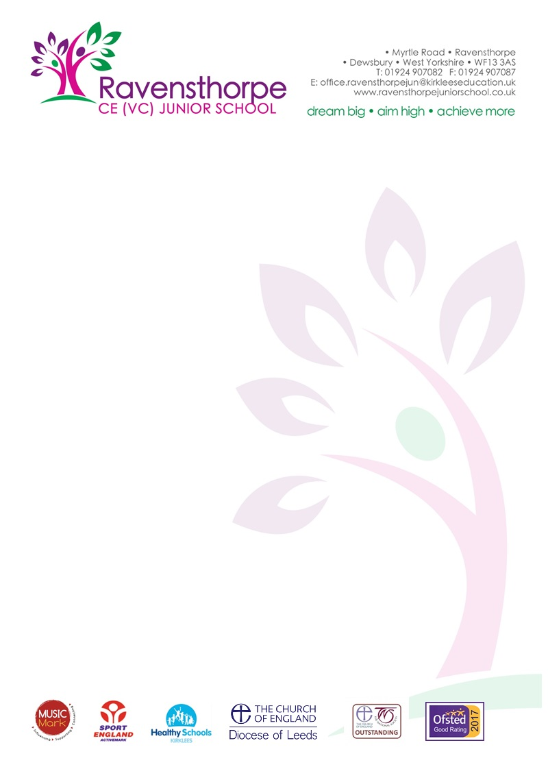

Tuesday 20th November 2018

Dear Parents/Carers

Sunday Times Parent Power Guide
The annual Sunday Times Parent Power List of the top 250 state primary schools in England was published at the weekend. Ravensthorpe CE (VC) School was 120th on the list and is the only school in Kirklees to feature. There are almost 17,000 state primary schools in England so we ae delighted that our hard work and commitment has been recognised.

Children in Need Day
I wrote to you last week to let you know that we will be raising money for Children in Need this Friday, 23rd November. Friday will be a non-uniform day – wear something spotty for a 50p donation. There will also be a bun sale, 20p per bun and we will be selling Pudsey Ears for £2.50 and glow in the dark wrist bands for £1. All money raised will go to Children in Need.

Homework
Please make sure your children complete their homework and return it to school on time. Ask your child’s class teacher if you are unsure what they need to do.

Holidays in term time
Once again, please do not take your children out of school in term time. Visits abroad must be made in the school holidays. Penalty notices are issued in all but exceptional cases.

Yours sincerely

Mr A S Parkin
Headteacher

